_________________Pathfinder Club

Ranger
Workbook








Ranger Name:

Teacher:

Year:

General


Personal Details

Paste your photo here

My Name is…………………………………………….………..

My Address is ……………………………………………….…..

Email address……………………………………………………………………………………..

My Date of Birth is ……..…………..…..

I am …..... Years Old.
I

I confirm that I am an ACTIVE MEMBER of the _____________ Pathfinder Club.

Club Member Signature ________________________Date________

Pathfinder Leader Signature ____________________Date_______

Book Club Certificate – Report Form
[Compulsory Requirement]

Name………………………………………………… Age ……………….……..

Book Title ……………………………………………………………………………………………

Book Category………………………………………. Date(s) Read ……………………….………

Author ………………………………………………. ISBN No …………………….……………

Publisher …………………………………………… Year Published …………………………….

Report: …………………………………………………………………………………………………………

…………………………………………………………………………………………………………

…………………………………………………………………………………………………………

…………………………………………………………………………………………………………

…………………………………………………………………………………………………………

…………………………………………………………………………………………………………

…………………………………………………………………………………………………………

…………………………………………………………………………………………………………

…………………………………………………………………………………………………………\

…………………………………………………………………………………………………………

…………………………………………………………………………………………………………

…………………………………………………………………………………………………………

…………………………………………………………………………………………………………

…………………………………………………………………………………………………………

…………………………………………………………………………………………………………

Signed: ……………………………………………………………………….. Date: ……………
[Pathfinder]

Signed: ……………………………………………………………………………Date: …………….
[Club Leader/Counsellor]

Book Club Certificate – Report Form
[Compulsory Requirement]

Name………………………………………………… Age ……………….……..

Book Title ……………………………………………………………………………………………

Book Category………………………………………. Date(s) Read ……………………….………

Author ………………………………………………. ISBN No …………………….……………

Publisher …………………………………………… Year Published …………………………….

Report: …………………………………………………………………………………………………………

…………………………………………………………………………………………………………

…………………………………………………………………………………………………………

…………………………………………………………………………………………………………

…………………………………………………………………………………………………………

…………………………………………………………………………………………………………

…………………………………………………………………………………………………………

…………………………………………………………………………………………………………

…………………………………………………………………………………………………………\

…………………………………………………………………………………………………………

…………………………………………………………………………………………………………

…………………………………………………………………………………………………………

…………………………………………………………………………………………………………

…………………………………………………………………………………………………………

…………………………………………………………………………………………………………

Signed: ……………………………………………………………………….. Date: ……………
[Pathfinder]

Signed: ……………………………………………………………………………Date: …………….
[Club Leader/Counsellor]

Book Club Certificate – Report Form
[Compulsory Requirement]

Name………………………………………………… Age ……………….……..

Book Title ……………………………………………………………………………………………

Book Category………………………………………. Date(s) Read ……………………….………

Author ………………………………………………. ISBN No …………………….……………

Publisher …………………………………………… Year Published …………………………….

Report: …………………………………………………………………………………………………………

…………………………………………………………………………………………………………

…………………………………………………………………………………………………………

…………………………………………………………………………………………………………

…………………………………………………………………………………………………………

…………………………………………………………………………………………………………

…………………………………………………………………………………………………………

…………………………………………………………………………………………………………

…………………………………………………………………………………………………………\

…………………………………………………………………………………………………………

…………………………………………………………………………………………………………

…………………………………………………………………………………………………………

…………………………………………………………………………………………………………

…………………………………………………………………………………………………………

…………………………………………………………………………………………………………

Signed: ……………………………………………………………………….. Date: ……………
[Pathfinder]

Signed: ……………………………………………………………………………Date: …………….
[Club Leader/Counsellor]


Spiritual Discovery

The purpose of this section is to renew and develop the teenagers’ confidence in the
Bible as the Word of God, and to help them discover a saving relationship in Jesus,
leading to a decision of commitment and baptism.

1. Discover in group discussion:

a. What Christianity is
b. What are the marks of a true disciple? (Matthew 6:19-34;
Luke 14:26-33.)
c. The forces involved in becoming a Christian.



You will need a BIBLE for this requirement.

Write down your thoughts on the above questions:


You will need to insert additional sheets for this requirement.
Discuss the following questions:
1. What does the parable say about:
a. What God is like? (1 John 1:5-10; 4: 11-17)
b. What I am like? (Rom. 3:9-20)
c. What the GOOD NEWS about God is? (Mark 1:14, 15; Eph.l:13; 2 Cor. 4, Eph. 3:6-8)
d. How God deals with me? (Rom. 3:21-27)
e. How we walk with God? (I Peter 4:1-3, Col. 3:7-17)

2. Define what Christianity is, and what it offers you personally.

God Leads a Pretty Sheltered Life (Anonymous)
At the end of time, billions of people were scattered on a great plain before God's
throne. Some of the groups near the front talked heatedly - not with cringing shame, but with belligerence.

"How can God judge us? How can He know about suffering?" snapped a joking brunette. She jerked back a sleeve to reveal a tattooed number from a Nazi concentration camp. "We endured terror, beatings, torture, death!"

In another group, a black man lowered his collar. "What about this?" he demanded, showing an ugly rope burn. "Lynched for no crime but being black! We have suffocated in slave ships, been wrenched from loved ones, toiled till only death gave release."

Far out across the plain were hundreds of such groups. Each had a complaint against God for the evil and suffering He permitted in His world. How lucky God was to live in heaven where all was sweetness and light, where there was no weeping, no fear, no hunger, no hatred. Indeed, what did God know about what man had been forced to endure in this world? "After all, God leads a pretty sheltered life," they said.

So each group sent out a leader, chosen because he had suffered the most. There was a Jewish person, a black person, an untouchable from India, an illegitimate, a person from Hiroshima, and one from a Siberian slave camp. In the center of the plain they consulted with each other. At last they were ready to present their case. It was rather simple: Before God would be qualified to be their judge; He must endure what they had endured. Their decision was that God "should be sentenced to live on earth-as a man!" But, because He was God, they set certain safeguards to be sure He could not use His divine powers to help Himself.

Let Him be born a Jew.

Let the legitimacy of His birth be doubted, so that none will know who His father really is.

Let Him champion a cause so just, but so radical, that it brings down upon Him the hate, condemnation, and elimination efforts of every major traditional and established religious authority.

Let Him try to describe what no man has ever seen, tasted, heard, or smelled – let Him try to communicate God to men.

Let Him be betrayed by His dearest friends.

Let Him be indicted on false charges, tried before a prejudiced jury, and convicted by a cowardly judge.

Let Him see what it is to be terribly alone and completely abandoned by every living thing. Let Him be tortured, and let Him die! Let Him die the most humiliating death - with common thieves.

As each leader announced his portion of the sentence, loud mummers of approval went up from the great throng of people. When the last had finished pronouncing sentence, there was a long silence. No one uttered another word. No one moved. For suddenly all knew…God had already served His sentence.

After reading the short story "God Leads A Pretty Sheltered Life," record your conclusions below on how much God really cares for us and is prepared to give all to save us.

2. Participate in a Bible Marking Program on the Inspiration of the Bible.

List of some Bile texts marked.

3. Enrol at least three people in a Bible Correspondence Course.

Person 1

Name: Date:

Person 2

Name: Date:

Person 3

Name: Date:

4. Hold a current Memory Gem Certificate

You will need a BIBLE for this requirement.
You will also need the Memory Gem Gap Fill for your chosen texts.

Memorise 7 bible texts – ONE form each of the seven categories below for each class. (You may use whichever version of scripture you wish)

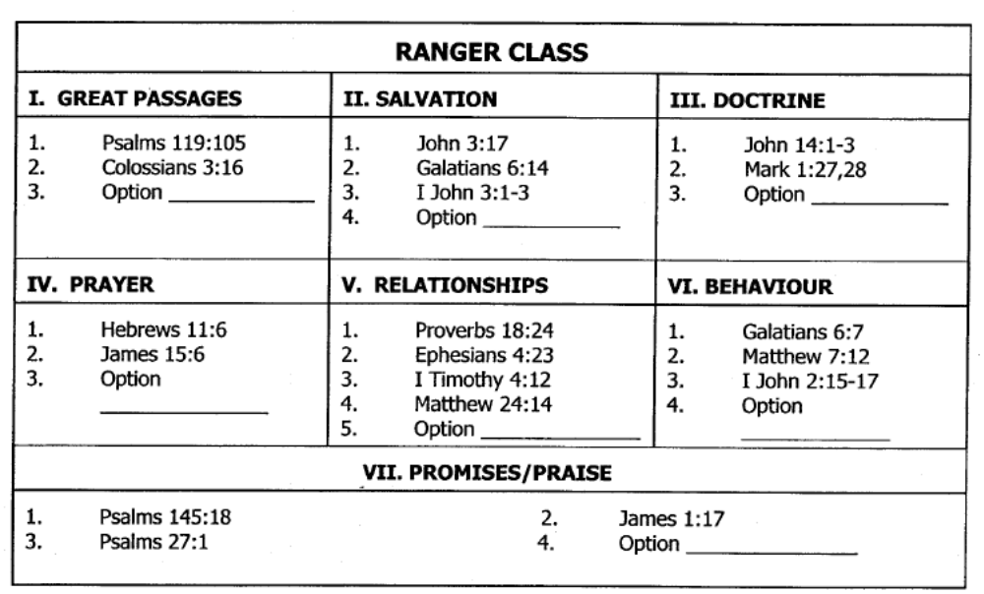

Write your 7 chosen bible texts below:

1. Great Passages……………………………………… Signature_______________

2. Salvation……….……………………………………… Signature_______________

3. Doctrine……………………………………………….. Signature_______________

4. Prayer……..…………………………………………… Signature_______________

5. Relationships………………………………………… Signature_______________

6. Behaviour……..……………………………………… Signature_______________

7. Promises/Praise.…………………………………… Signature_______________

(Please insert the Memory Gem “gap fill” and explanation as evidence of memorising your texts.)

Community Outreach


The aim of this section is to develop within the Rangers the skills and enjoyment of sharing their Christian beliefs.

1. Under the direction of your leader, participate at least once in two different types of outreach programs.

You will need to speak your COMMUNITY SERVICE leader in church for this requirement and participate in one of their planned activities.

Event 1 Name:

Place: Date:

Write a summary of the event you assisted in:

The outreach ministries may include the following programs:
a. Christian Servicesb. Church Projects
c. World Missiond. Unchurched People

Event 2 Name:

Place: Date:

Write a summary of the event you assisted in:

The outreach ministries may include the following programs:
a. Christian Servicesb. Church Projects
c. World Missiond. Unchurched People

2. With the help of a friend spend a full day (at least 8 hours)
working on a project for your church, school, or community.
This could be any program including AYS, Sabbath School, Children’s Day or a Community Program or the Hyland House annual school fete.

Summarise your participation below:

1.___________________________


Friendship Development

1. In group discussion and by personal inquiry, examine your attitudes to two of the following topics:

A. Self-confidence (Additional resources in Explorer class under Health & Fitness)
B. Friendship
C. The Social Graces
D. Will Power

Topic 1:_________________________________

Write a summary of your discussion/outline in this space:

Topic 2:_________________________________

Write a summary of your discussion/outline in this space:

The outreach ministries may include the following programs:
a. Christian Servicesb. Church Projects
c. World Missiond. Unchurched People

The outreach ministries may include the following programs:
a. Christian Servicesb. Church Projects
c. World Missiond. Unchurched People

The outreach ministries may include the following programs:
a. Christian Servicesb. Church Projects
c. World Missiond. Unchurched People

Health and Fitness



The aim of this section is to give practical guidelines which will help to strengthen the
Ranger's desire to care for his mind and body.

1. Participate in one of the following:
a. Discuss the principles of physical fitness.
- Provide an outline of your daily exercise Program.
- Write out and sign a Personal Pledge of Commitment to a regular exercise program.

The Principles of Physical Fitness
Write a summary of your discussion below:

You can also show evidence by creating a PowerPoint presentation, writing a poem, designing a poster and putting on a presentation or performance.
Provide an outline of your daily exercise Program.

Sunday

Monday

Tuesday

Wednesday

Thursday

Friday

Saturday

Write out and sign a Personal Pledge of Commitment to a
regular exercise program.

You can design a pledge card and stick it below or write you pledge in the space below.

b. Discuss the natural advantages of living the Adventist Christian
lifestyle in accordance with biblical principles.

Write a summary of your discussion in this space:

Organisation and Leadership

Development

- Attend at least one church business meeting.

Walthamstow Church Business Meeting

Date: Place:
Write a summary of what took place:

Include the agenda for the church business meeting.

2. With your group make plans for a social activity at least once a
quarter.

Outside the Sabbath Hours:
Plan your activity in keeping with the principles of ` Christian recreation.

Suggestions for activities include:

- Games Evening Barbecue and Bonfire ➢ Progressive Party Homes Evening
- Hay Ride Film Night ➢ Hobby Night Sports Center
- Concert Reverse Night ➢ Display Night Moonlight Hike
- (gymnastics, etc.) Observation Evening

Write a summary of what took place:

1st Quarter

Event: ____________________________________________

2nd Quarter

Event: ____________________________________________

3rd Quarter

Event: ____________________________________________

4th Quarter

Event: ____________________________________________


Nature Study

1. Review the story of the flood and study at least three different
fossils.
Explain their origin and relate them to breaking God's Laws.

Write a summary of the flood story in the space below:

You will need a copy of Early Writings by E.G White.
This can be borrowed from the church library.

This requirement could include a visit to a museum and study the fossils there. – if time permits.
The outreach ministries may include the following programs:
a. Christian Servicesb. Church Projects
c. World Missiond. Unchurched People

Study at least three different fossils.

You can stick it a fossil images below or draw them in the space below

Fossil 1:

Fossil 2:

Fossil 3:

Explain their origin and relate them to breaking God's Laws.

2. Complete a Nature Honour not previously earned.

Honour:

Signature____________________________________

Honour:

Signature____________________________________

Please insert completed Honour Requirements and any other supporting evidence i.e. photos.
Honour:

Signature____________________________________
Outdoor Life


The purpose of this section is to have the Rangers continue developing
their outdoor living and safety skills.

1. Build and demonstrate the use of a reflector oven by cooking something.
List the items need to build a reflector oven and explain how to build it.:

Recipe:
List the ingredients used and method of making your meal.

Ingredients:

Method:

- Participate in a two-night CAMP OUT. Be able to pack a ruck
sack, include personal gear and food sufficient for your participation.

Consider the following when packing:
- Gear list
- Something to eat with
- Something to sleep in
- Something to keep dry in
- Something to keep warm in
- Something to have fun in
- Something to keep clean with
- Miscellaneous

Date of Camp-Out:______________________________

Event:____________________________________________

Method of packing / Items to pack:

Cont’d

Rangers following the DofE Curriculum can meet these requirements. These can also be met at the annual Camporee.

3. Pass a test in Ranger first aid.

Ranger First Aid Notes

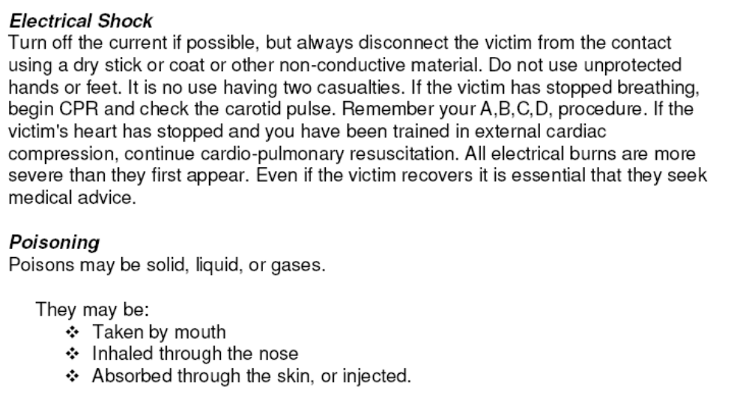

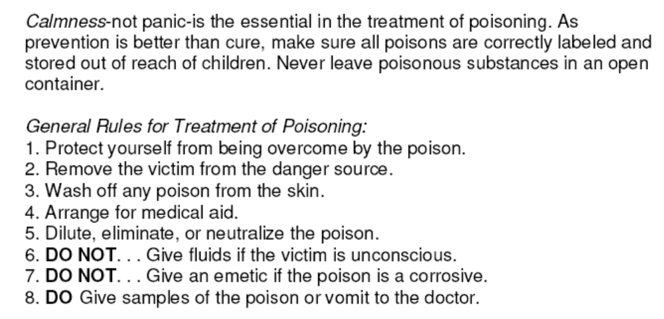

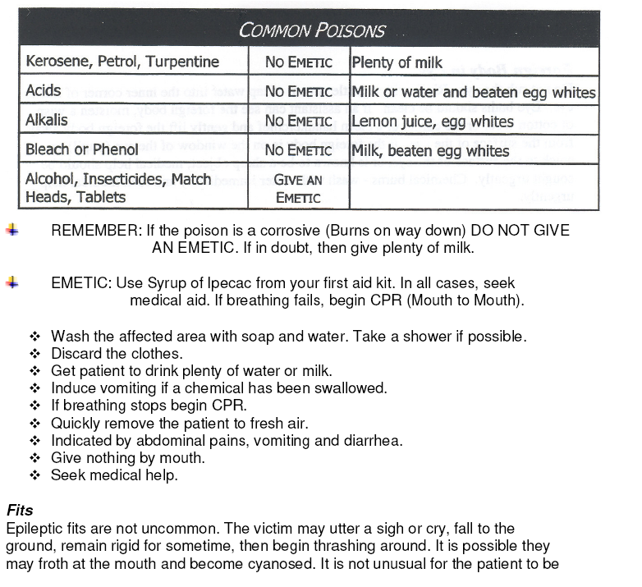

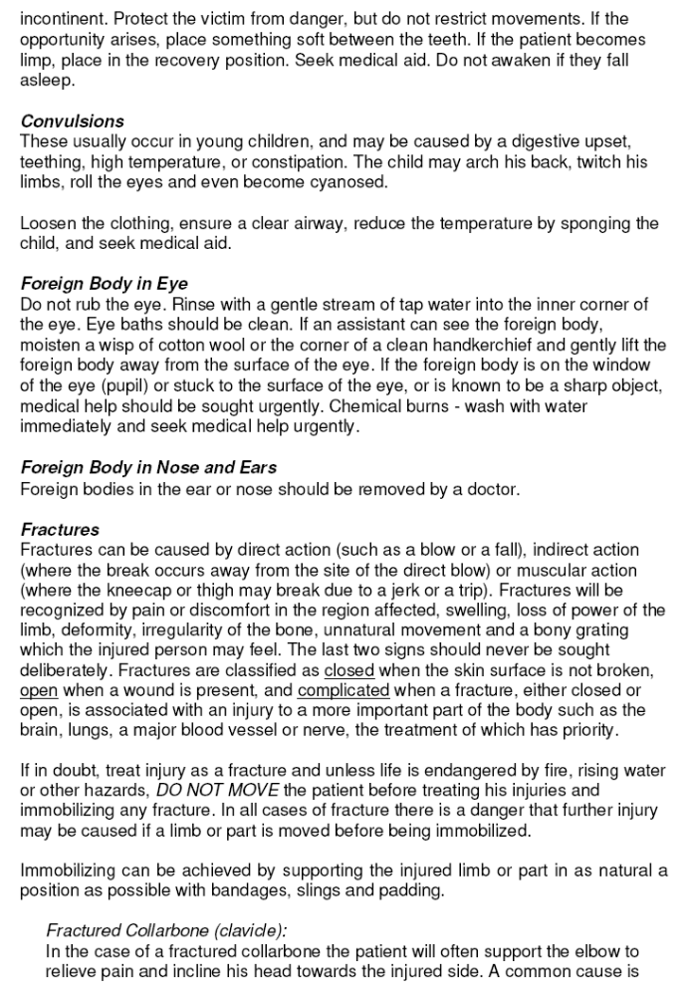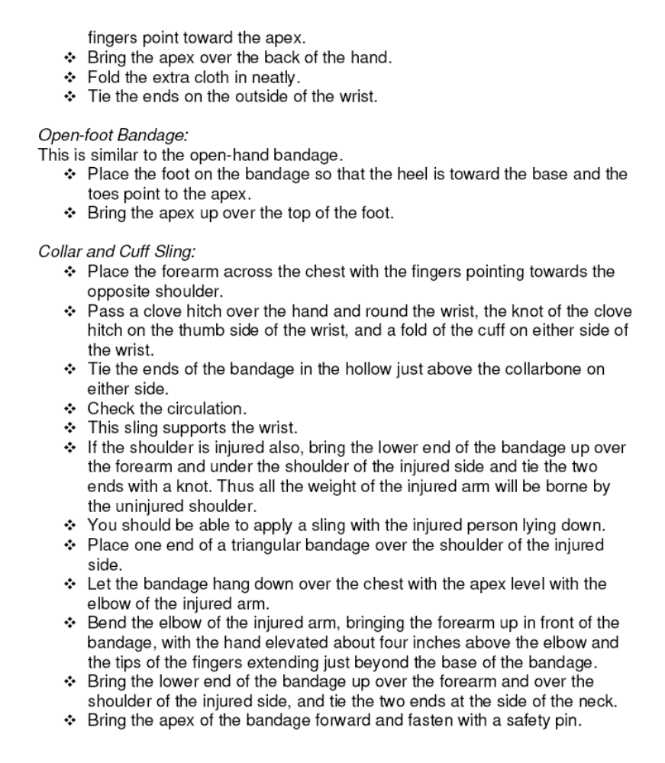

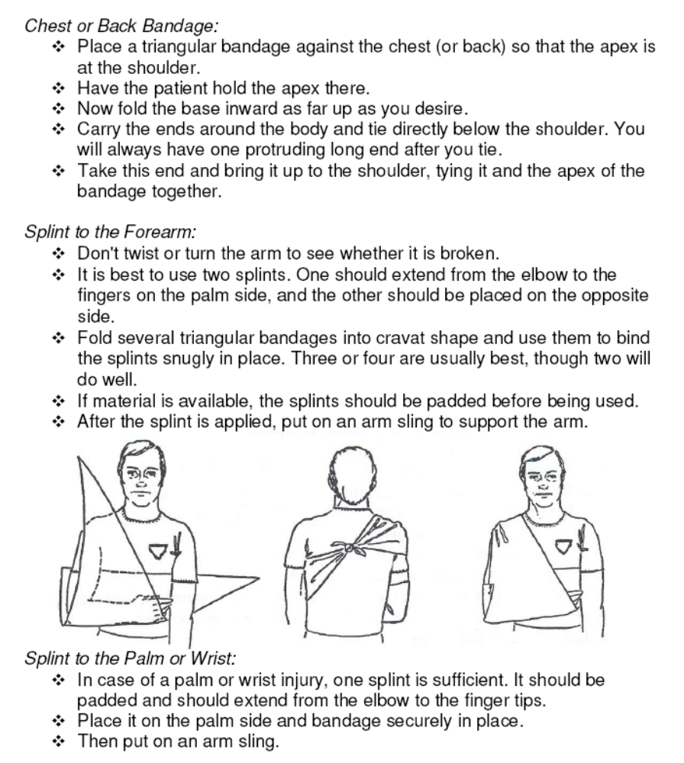
Method of Testing

The instructor will give the examination.

Ranger first aid does NOT complete the First Aid Honour, nor is the certificate awarded.

If one chooses to complete the current St. John or Red Cross First Aid Certificate,
then this will meet the requirements for Ranger, Voyager and Guide.

Lifestyle Enrichment


- Complete one honour not previously earned in Outreach Ministry, Vocational, or Outdoor Industries.

Honour:

Signature____________________________________

Honour:

Signature____________________________________

Please insert completed Honour Requirements and any other supporting evidence i.e. photos.
Honour:

Signature____________________________________

